Assignment 2 – MLE

Part 3: (40 points)

1. Write the expression of the Negative Log Likelihood NLL.

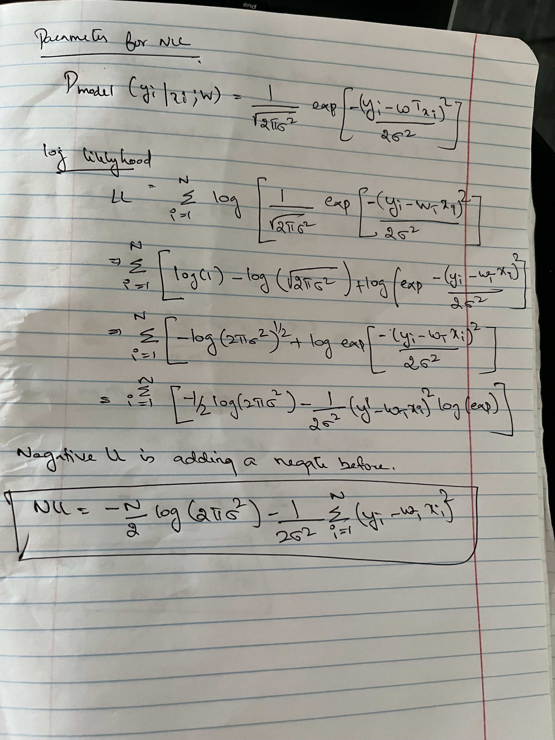

1. Write the parameters w and the σ2 that minimize the NLL (10 points)

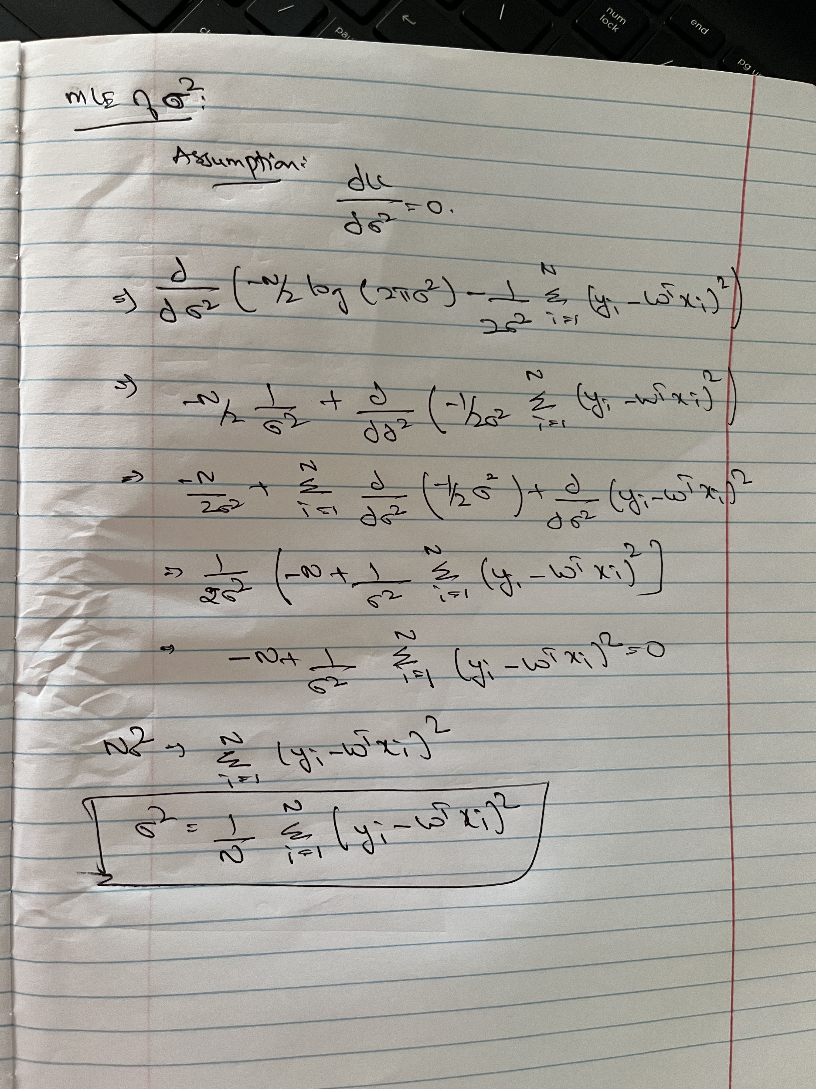

1. Write the parameters w and the σ2 that minimize the NLL (10 points)

